**Project Design Phase-II**

**Technology Stack (Architecture & Stack)**

| Date | Please Enter the date |
| --- | --- |
| Team ID | Please Enter your Team ID |
| Project Name | Garbage Classification Using Deep Learning |
| Maximum Marks | 4 Marks |

**Technical Architecture:**

The Deliverable shall include the architectural diagram as below and the information as per the table1 & table 2

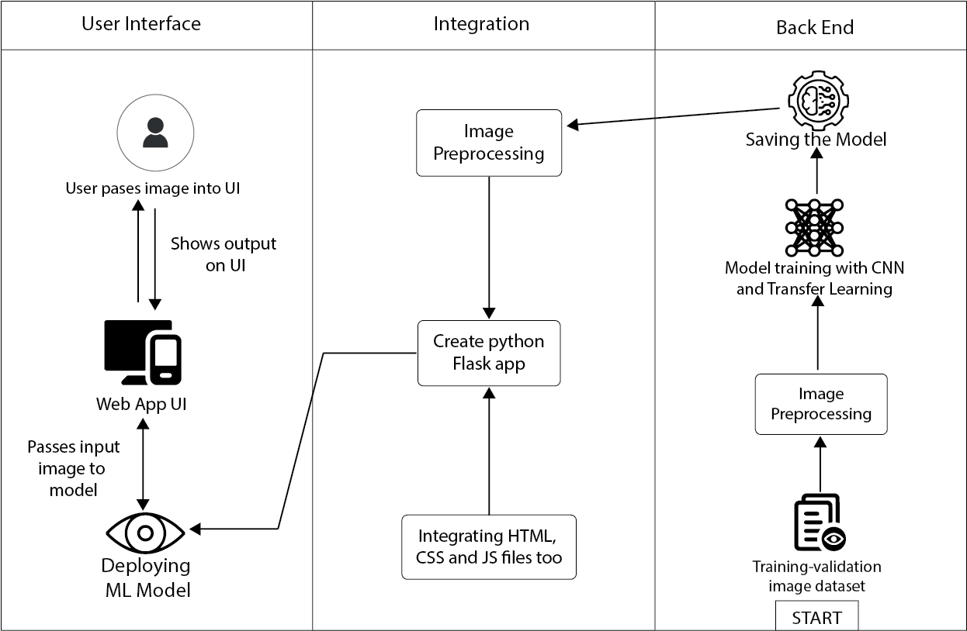

**Table-1 : Components & Technologies:**

| **S.No** | **Component** | **Description** | **Technology** |
| --- | --- | --- | --- |
| 1. | User Interface | How user interacts with application e.g.  Web UI | HTML, CSS, JavaScript. |
| 2. | Application Logic-1 | Logic for a process in the application | Python Flask web app |
| 3. | Database | Collect the Dataset Based on the Problem Statement | File Manager, etc. |
| 4. | File Storage/ Data | File storage requirements for Storing the dataset | Local System, Google Drive Etc |
| 5. | Frame Work | Used to Create a web Application, Integrating Frontend and Back End | Python Flask |
| 6. | Deep Learning Model | Purpose of Model | CNN and Transfer Learning |
| 7. | Infrastructure (Server / Cloud) | Application Deployment on Local System / Cloud Local Server Configuration:  Cloud Server Configuration : | Localhost port: 5000 |

**Table-2: Application Characteristics:**

| **S.No** | **Characteristics** | **Description** | **Technology** |
| --- | --- | --- | --- |
| 1. | Open-Source Frameworks | List the open-source frameworks used | Python’s Flask library |
| 2. | Security Implementations | List all the security / access controls implemented, use of firewalls etc. | - |
| 3. | Scalable Architecture | Justify the scalability of architecture (3 – tier, Micro-services) | Cloud Services |
| 4. | Availability | Justify the availability of applications (e.g. use of load balancers, distributed servers etc.) | Web hosting (Github Pages) |
| 5. | Performance | Design consideration for the performance of the application (number of requests per sec, use of Cache, use of CDN’s) etc. | - |